**[Build & Deploy a Production-Ready Patient Management System with Microservices: Java Spring Boot AWS](https://www.youtube.com/watch?v=tseqdcFfTUY)**

What you will learn:

* Java, Spring boot and docker microservices
* Postgres Databases
* Load Balancers and API Gateways to route requests
* Event Driven communication – Kafka
* Real time communication – rest and GRPC
* Authenticate users and secure APIs using bearer tokens
* Integration tests
* Deploying to AWS using localstack and infrastructure as code

We are going to be building a real-world, enterprise level application (a Patient Management System) using microservices.

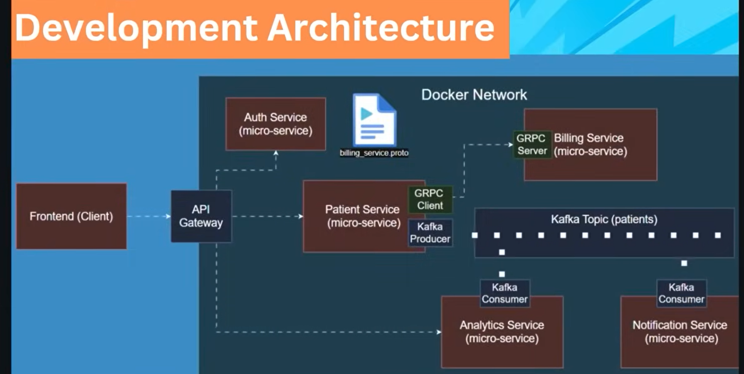

By the end of this course, we will know how to take an enterprise system from local development to FULL-CLOUD DEPLOYMENT.

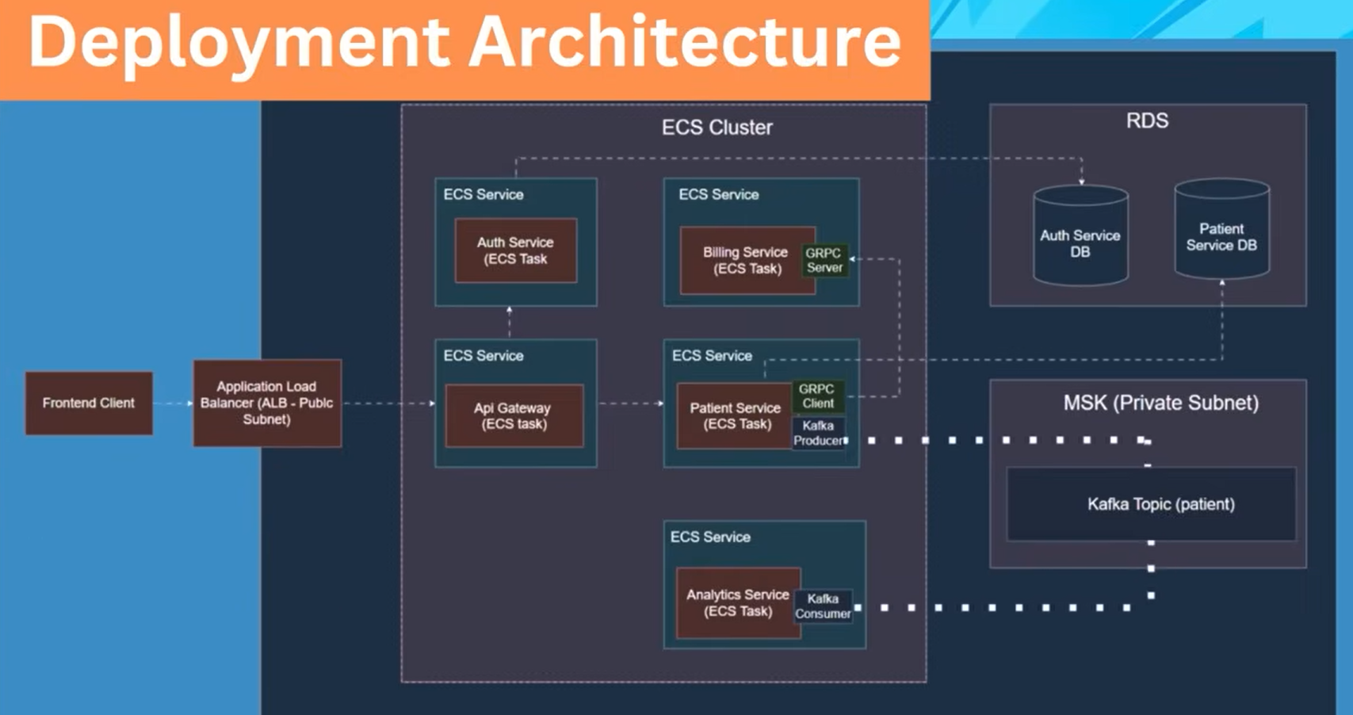

**JDK (Java Development Kit)** = a comprehensive software package that provides the tools, compilers, and libraries necessary to write, compile, debug, and run Java applications. It is the foundational component for any Java developer.

**Key Components of the JDK**

The JDK is a superset that includes the Java Runtime Environment (JRE) as well as additional development tools.

* **Java Runtime Environment (JRE):** This is the "runtime" part of the software, containing the Java Virtual Machine (JVM) and the core class libraries needed to *execute* already compiled Java programs. End-users who only need to run Java applications typically only need the JRE.
* **Development Tools:** These are the utilities that distinguish the JDK from the JRE and are used by developers to create programs. Key tools include:
  + **javac:** The Java compiler, which translates human-readable Java source code (.java files) into platform-independent bytecode (.class files).
  + **java:** The application launcher/interpreter, which starts the JVM and executes the bytecode.
  + **jdb:** The debugger, used to find and fix bugs in Java programs.
  + **jar:** The archiver tool, used to package related class files and resources into a single Java Archive (JAR) file for efficient storage and distribution.
  + **javadoc:** The documentation generator, which automatically creates HTML API documentation from comments in the source code.
  + **Monitoring and Management Tools:** Utilities like jconsole and jmc for monitoring Java application performance.

**JDK, JRE, and JVM Relationship**

The three core Java technologies work together in a layered structure:

* **JDK** (Development Kit) = includes **JRE** + Development Tools
* **JRE** (Runtime Environment) = includes **JVM** + Class Libraries
* **JVM** (Virtual Machine) = the engine that executes the Java bytecode
* This architecture is what enables Java's "Write once, run anywhere" philosophy, as the platform-specific JVM translates the universal bytecode into the native machine code for the host operating system (Windows, macOS, Linux, etc.).

**Docker** = Docker is a popular platform used for running applications in containers, which are indeed a fundamental technology in a microservices architecture. Containers provide a consistent and isolated environment for each service, simplifying development, deployment, and scaling across different systems.

In a microservices application, each independent service is typically packaged into its own container. This approach offers several key benefits:

* **Isolation**: Each container operates in isolation, ensuring that one service's dependencies or issues do not impact others.
* **Portability**: Containers package the application code and all its dependencies, allowing the service to run consistently on any environment (developer's laptop, staging server, production cloud).
* **Scalability**: Individual services can be scaled up or down independently as needed by deploying more container instances, without affecting the entire application.
* **Efficiency**: Containers are lightweight and start quickly, which improves deployment speed and resource utilization compared to traditional virtual machines.

Tools such as Docker help manage this ecosystem by providing the means to build container images, run containers, and orchestrate how they communicate and operate together in complex applications.

* INSTALL JAVA JDK
* INSTALL DOCKER DESKTOP
* INSTALL JETBRAINS INTELLIJ IDEA ULTIMATE IDE

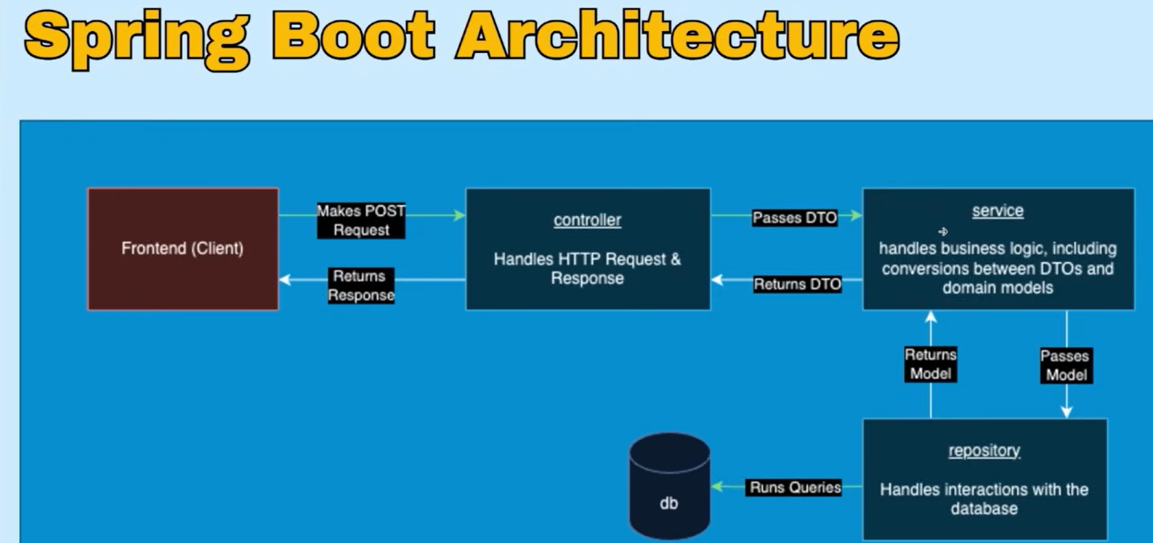

The Spring Boot architecture is a **layered structure** designed to separate concerns, making the application modular, scalable, and maintainable. This diagram illustrates the classic four-layer approach: Presentation (Controller), Business (Service), Persistence (Repository), and Database.

**1. The Frontend (Client)**

This is the entry point, often a web browser or mobile app, that initiates communication with your microservice.

* It typically makes HTTP requests (like **GET** or **POST**) to the server.

**2. The Presentation Layer (Controller)**

The Controller is the first layer of the application that interacts with external clients.

* **Handles Requests:** The controller is responsible for receiving and handling the incoming HTTP requests and formulating the HTTP responses.
* **Validation:** It performs initial validation, such as checking if required properties exist in the request body.
* **Passes Data:** After basic validation, it decides what to do with the request and passes the data (usually in the form of a **DTO**) to the appropriate service layer.

**3. The Business Layer (Service)**

The Service layer contains the core business logic and rules of the application.

* **Handles Logic:** This is where you implement logic like ensuring a patient's email address is unique or checking if a user meets specific criteria before registration.
* **External Calls:** It orchestrates workflows and can make necessary external calls to fulfill the business requirements.
* **Conversions:** A key function described in your video is converting the incoming **DTO** into a **domain model** (or entity) object that represents the actual data structure used internally by the application before passing it down to the persistence layer.

**4. The Persistence Layer (Repository)**

The Repository layer is solely responsible for data access and managing interactions with the database.

* **Database Interactions:** It hides away raw **SQL queries**, allowing the service layer to interact with the database using simple model objects instead of complex SQL commands.
* **CRUD Operations:** When the service layer calls the repository layer (e.g., to create a patient record), the repository executes the necessary queries against the database.

**5. The Database Layer**

This is where all the application's data is physically stored and retrieved.

**The Role of Data Transfer Objects (DTOs)**

A DTO is a simple Java or JavaScript object used purely to pass data efficiently between different layers, specifically between the controller and the service layer.

DTOs are used for several crucial reasons:

* **Hides Internal Structure:** They prevent the exposure of internal database entity fields (the "domain models") to the client, protecting your application's internal structure.
* **Field Filtering:** They allow you to send or receive only the fields relevant to the client. For example, a patient DTO might omit sensitive private medical information that exists in the full database model.
* **Early Validation:** Using DTOs for validation in the controller means errors can be returned to the client much earlier in the request lifecycle, improving performance and user experience.

**Inter-Service Communication**

In a microservice architecture, services often need to interact to fulfill complex requests.

* **Synchronous Communication:** A service can call another service's API using protocols like HTTP/REST (e.g., using Spring's RestTemplate or FeignClient), waiting for a response.
* **Asynchronous Communication:** Services can communicate via a message broker (like Kafka or RabbitMQ) in an event-driven architecture. A service sends a message (event) and does not wait for an immediate response, which helps decouple services.

**Best Practice: Unique Email Check**

For a simple uniqueness check, the best practice is to handle it within the **same service** (e.g., a UserService or PatientService) that manages the user's data.

* **Single Responsibility Principle:** Each microservice should own its data and be responsible for the business logic related to that data.
* **Data Integrity:** The service that manages patient records is the single source of truth for patient emails. It's best equipped to enforce the rule that emails must be unique.
* **How it Works:** In your service layer, before saving a new patient model to the database via the repository, you would make a call to your repository (e.g., userRepository.findByEmail(email)) to see if an email already exists. If it does, you throw a business exception (like DuplicateEmailException) and return an error to the client.
* **Avoids Tight Coupling:** Calling another service for a simple data validation creates unnecessary coupling and introduces latency and potential network failures into a single transaction.

Calling another service is generally reserved for operations that require data or logic from a different, genuinely independent domain (e.g., a "Billing Service" calling an "Email Service" to send an email after a successful payment).

* <https://www.youtube.com/watch?v=xYv3tBvJavM> – Spring boot explained
* <https://www.youtube.com/watch?v=rv4LlmLmVWk> --- Microservices explained

**DOMAIN-FIRST / INSIDE-OUT ARCHITECTURE**

**---- NOTE: I HAVE NOTICED WE BUILD THE APP BOTTOM UP ARCHITECTURE. FOR EXAMPLE, START WITH MODEL/ENTITY 🡪 REPOSITORY 🡪 SERVICE 🡪 DTO 🡪 CONTROLLER ----**

You start with the most fundamental part—the data definition—and build outwards toward the user interface or API boundary.

The "Bottom-Up" or “Inside-Out” Flow Explained

**1. Model/Entity Layer**

You start here because you must first define what data your application manages. This layer is technology-agnostic and defines the core rules of your business domain.

**2. Repository Layer**

Once you have the entity defined, you create the interfaces (Repositories) that describe how you plan to save and retrieve that data from a database (e.g., using a JpaRepository).

**3. Service Layer**

This layer contains your actual business logic. It uses the repository interfaces to orchestrate operations. It uses the entities defined in Step 1 to perform actions.

**4. DTO & Mapper**

This step is about preparing the data for transfer outside the core service layer. The service decides which parts of the entity should be exposed and uses a Mapper to create a Data Transfer Object (DTO).

**5. Controller Layer**

This is the outermost layer (the "top") where the application receives inputs (HTTP requests). The controller simply calls the service layer, receives the prepared DTO, and sends it back to the client as a JSON response.

This structure ensures strong separation of concerns and makes your application easier to test and maintain, as each layer has a single, clearly defined responsibility.

**PATIENT SERVICE**

**Use IntelliJ Ultimate to create an Empty Project.**

* Patient-management project folder 🡪 Create a New **MODULE**. A Module is going to be a standalone microservice.
  + *{Anytime we add a new module we are essentially creating a new microservice}*
  + 
  + Choose Spring Boot and input Name (eg. patient-service), Java, Maven (Package manager), Group (com.pm), JDK.
  + Select Dependencies like Spring Web, Spring Data JPA, Spring Boot DevTools, PostgresSQL Driver, Validation.
  + **Spring Web:** This dependency is used for building web applications and RESTful APIs using the Spring MVC framework. It embeds a servlet container (like Tomcat or Jetty), which means you can run your application as a standalone JAR file without needing to deploy it to an external server.
  + **Spring Data JPA**: This dependency simplifies the implementation of data access layers using the Java Persistence API (JPA). It dramatically reduces the amount of boilerplate code needed for database operations by automatically generating repository implementations for common CRUD (Create, Read, Update, Delete) methods and allowing you to define custom queries through method names.
  + **PostgreSQL** **Driver**: This is the actual JDBC (Java Database Connectivity) driver, a software component that enables your Java application to connect and interact seamlessly with a PostgreSQL database. It acts as the communication bridge between the generic data access code (written using Spring Data JPA) and the specific database management system (PostgreSQL).
  + **Validation**: This dependency (typically part of spring-boot-starter-web or added explicitly as a spring-boot-starter-validation) provides support for the Java Bean Validation API (Jakarta Bean Validation). It allows you to use annotations (e.g., @NotNull, @Size, @Min) on your Java objects (entities or DTOs) to enforce data integrity and constraints, simplifying input validation logic.
  + **CREATE MODULE**
* **Application.properties** file in the Resources folder.
  + The **application**.**properties** file is a crucial configuration file in Spring Boot, used to customize an application's behavior and settings without modifying the core Java code. It's a plain text file typically located in the src/main/resources directory of a project and uses a simple **key=value** format.
  + Some frequently used properties include Server properties (port, base URL path), DB configurations, Logging configurations, metadata.
  + 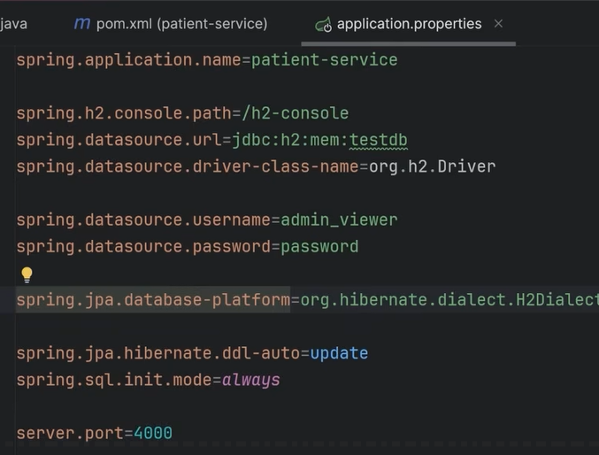
* **JAVA** **FOLDER** = In a standard Maven or Gradle Spring Boot project, the core Java source code is located in the src/main/java folder, while test code is placed in src/test/java.
  + 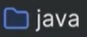
* Entry point to the App which contains the public static void main class. @SpringBootApplication tells Spring Boot, ‘this is the entry point to our app’.
  + 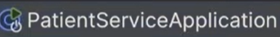
* **pom.xml** (Project Object Model) is the central configuration file used by **Maven** to manage the project's build process, dependencies, and project metadata. It acts as a "blueprint" that tells Maven the build configurations and exactly how to compile, package, and run the application. Any new dependencies are added here!
* Create New Package. (com.pm.patientservice.**model**)
  + This model will hold all the domain entities that this microservice is responsible for.
* **Persistence Level (The “Architecture Layer”) =** The **Persistence Level** (or Persistence Layer) is the broader architectural category that contains both Entities and Repositories.
  + **Role**: It is responsible for making data "persist" (stay saved) even after the application or server restarts.
  + **Contents**: It includes your **entities**, **repositories**, **database configurations**, and the **JPA/Hibernate engine** that manages them.
  + **Purpose**: To separate data access code from the business rules (Service Layer), making the app easier to maintain and test
* **@Entity**. **Patient Class**. New Java Class in the Model folder.
  + **Entity Definition = a thing with distinct and independent EXISTENCE**.
  + An Entity is a Java Class that maps directly to a table in your database.
  + This Entity is going to get represented as a table in the DB and each of the properties are going to be represented as a column. This will all be handled by the JPA Persistence layer and the @Repository.
  + Annotated with @Entity, it defines columns, primary keys (@Id), and relationships (like @OneToMany). This allows you to work with database records as Java objects rather than raw SQL rows.
  + **Entity Annotations** = @Id, @GeneratedValue, @NotNull, @Email, @Column
  + Create public Getters and Setters for all private properties.
  + **Automatic Entity Synchronization with JPA**
    - When you start a Spring Boot application, it can automatically **synchronize your Java entities (classes annotated with @Entity) with the database schema**.
    - This means: If a table (e.g., patient) does not exist in the database, Spring (via JPA/Hibernate) will create it.
    - If the table exists but is missing columns that are defined in your entity class, those columns will be added.
    - This feature saves you from manually creating tables and columns in the database.
  + **Why is this Powerful?**
    - Anytime you create a new entity in your code, it will automatically be reflected in the database.
    - You don’t need to manually write SQL scripts for table creation or column updates.
    - It ensures consistency between your **Java model** and the **database schema**.
  + **In-Memory Database for Development**
    - For quick testing and development, Spring provides **in-memory databases** like **H2**.
    - These databases run in memory, so you don’t need to set up a full database server.
    - Fast and easy to use during development.
    - Great for testing whether your microservice (e.g., Patient Service) interacts correctly with the persistence layer.
    - You can get the DB console running on the same microservices localserver:port:  
      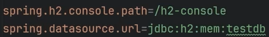

**Repository**

* Handles interactions with the database. The **Repository** is the specific component within the persistence level that manages all database interactions.
* **Key Responsibilities of a Repository**
  + Data Abstraction: It provides a clean API for the rest of the application (like the Service layer) to perform data operations without needing to know the specific database technology or query language being used.
  + CRUD Operations: It handles standard tasks such as creating, reading, updating, and deleting records (e.g., save(), findById(), delete()).
  + Query Methods: It allows developers to define custom searches simply by naming methods (e.g., findByLastName) which Spring Data JPA automatically converts into SQL.
  + Exception Translation: When annotated with @Repository, Spring automatically catches low-level database errors (like SQLException) and converts them into more readable, unified Spring data access exceptions.
* Create new Repository package 🡪 src/main/java/com.pm.patientservice/repository
* Create New Java Class called PatientRepository and select Interface.
  + Add @Repository and extends JpaRepository<entity, entityId> 🡪 tells Spring this interface is a JPARepository
  + **JpaRepository** is a powerful interface provided by Spring Data JPA that significantly reduces boilerplate code for database interactions. It serves as a specialized extension of the standard Repository and CrudRepository interfaces. ***You get a lot of out-of- the-box functionality.***
    - **Core Functionality:**
    - Built-in CRUD: It provides standard methods for common operations like save(), findById(), findAll(), and deleteById() out-of-the-box.
    - Pagination and Sorting: Unlike a standard CrudRepository, it inherits from PagingAndSortingRepository, allowing you to easily handle large datasets by splitting results into pages or sorting them by specific fields.
    - JPA-Specific Operations: It includes advanced persistence methods such as flush() (to synchronize the database with the current state in code) and saveAndFlush().
    - Batch Operations: It supports efficient bulk actions like deleteInBatch().
* **CUSTOM REPOSITORY QUERY METHODS:  
  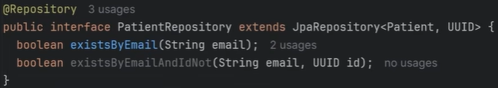**
* The **existsByEmail(String email)** method uses a powerful feature in **Spring Data JPA** called **derived query methods**, where the framework automatically generates the required SQL query from the method name itself.
* This is known as **derived query methods** or **query by method name** in ***Spring Data JPA***. The framework parses the method name to automatically generate the corresponding SQL or JPQL query at runtime.
* Spring Data JPA uses a **"convention over configuration"** approach. It breaks the method name into two main parts around the first **By** keyword:
  + **The Introducer (Prefix):** The part before **By** specifies the type of operation (e.g., find, exists, count, delete).
  + **The Criteria (Predicate):** The part after **By** specifies the conditions for the **WHERE** clause, using entity property names and various keywords.
  + **Examples:** deleteByEmail, findByActiveIsTrue, findByStartDateBetween, findByNameContaining, findByStatusAndCategory, countByAgeGreaterThan, existsByEmail, findById, findByName
* Now this custom QUERY we added to the PatientRepository using Spring Data JPA will be used in the Service Layer! **existsByEmail()**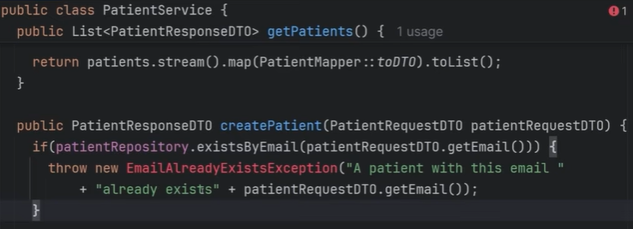

**Response DTO**

* Create New Package. (com.pm.patientservice.**dto**)
* New Class. (PatientResponseDTO)
  + This DTO will contain all and only the properties that we want to return to the frontend CLIENT. It is very similar to the Domain Entity Model, but we don’t want to return the exact Entity structure and data to the CLIENT. For example, some fields like password, regsteredDate etc are missing from DTO. Also, some of the TYPES are different like LocalDate and UUID vs String (*There can be issues sometimes in converting these types and the Entity into a JSON*). So, it is best practice to convert the Entity to a DTO.
  + **Public class PatientResponseDTO {  
     private String id;  
     private String name;  
     private String email;  
     private String address;  
     private String dateOfBirth;  
    }**
  + Generate Getters and Setters
  + THIS **PatientResponseDTO**() CAN NOW BE USED IN THE **PatientService**().

**Service**

* **The Service layer** acts as the "brain" of your application. It is the layer where you implement all core business logic and orchestrate data flow between other parts of the system.
* **Primary Responsibilities:**
  + **Business Logic Implementation**: This folder contains the rules that define how your business operates (e.g., calculating discounts, validating if a user is eligible for an upgrade, or processing a complex payment).
  + **Layer Intermediary**: Services act as a bridge between Controllers (which handle web requests) and Repositories (which handle database access). This prevents your web layer from becoming bloated with complex logic.
  + **Transaction Management**: It defines transactional boundaries using the **@Transactional** annotation. This ensures that if a service method performs multiple database operations, they either all succeed or all roll back if an error occurs, maintaining data integrity.
  + **Data Transformation**: Services are responsible for converting database entities into Data Transfer Objects (DTOs) before sending them back to the controller, ensuring internal database structures are not exposed directly to the outside world.
  + **Cross-Service Orchestration**: In larger systems, one service may call multiple repositories or even other services to complete a single user request.
* Create New Class called PatientService
  + Add @Service. We will do all the business logic and DTO conversions.
  + Some dependency injection:
    - ***Private PatientRepository patientRepository;  
      Public PatientService(PatientRepository patientRepository) {  
       this.patientRepository = patientRepository;  
      }***
  + **Dependency Injection (DI)** is a design pattern where a class does not create the objects it needs (its dependencies). Instead, those objects are "injected" into the class from the outside.
  + In this specific example, PatientService needs PatientRepository to function. Instead of the service creating a new repository itself (using new PatientRepository()), it asks for one via its constructor.
    - **The Requirement**: PatientService says, "I cannot work unless I have a PatientRepository."
    - **The Hand-off**: When your application starts, Spring Boot (the "Inversion of Control" container) sees that PatientService needs a repository.
    - **The Resolution**: Spring looks in its "toolbox" (the Application Context), finds the PatientRepository bean it already created, and passes it into the PatientService constructor automatically.
    - **Why is this better than using new?**
    - **Loose Coupling**: PatientService doesn't need to know how to create a repository or which specific database it uses. It just knows it has one that works.
    - **Easier Testing**: When writing a unit test for PatientService, you can easily "inject" a fake (mock) repository instead of a real database. This allows you to test your business logic in isolation.
    - **Singleton Management**: Spring ensures that only one instance of PatientRepository is created and shared across your entire application, saving memory.
  + Now remember in the Service class, we need to get the Domain Entity Model and convert it to DTO’s.
    - **Domain Entity Model** is a Java class that serves as a blueprint for real-world concepts in your business (like a Patient) and acts as a direct representation of a database table. 🡪 *An ENTITY is a direct representation of a database table.*
* **Public class PatientService {**

**// Dependency Injection  
private final PatientRepository patientRepository;  
// This constructor is telling Spring that we NEED this patientRepository dependency for this class to work, you please inject it for us  
public PatientService(PatientRepository patientRepository) {  
 this.patientRepository = patientRepository;  
}**

**public List<PatientRepositoryDTO> getPatients() {**

**// 1. Fetch DOMAIN ENTITIES from the database via the Repository**

**List<Patient> patients = patientRepository.findAll();**

**// 2. (Implicit next step) Convert/Map these entities into DTOs**

**// to send back to the user/API layer.**

**List<PatientResponseDTO> patientResponseDTOs = patients.stream()  
 .map(patient 🡪 PatientMapper.toDTO(patient)).toList() ;  
  
 return patientResponseDTOs ;**

**}**

* + Each individual instance (object) of the **Patient** class represents exactly one row in the real Patient table in the DB.
    - **The Class (Patient) = The Table (patient).**
      * So, in this code, the **patients** instance would represent the entire **Patient** table.
    - And EACH **Patient** Object Instance in the **patients** List<> represents one row/record.
    - **The Fields (name, age) = The Columns.**
    - **The DTO mapping part of the code snippet you highlighted uses a Java 8 Stream API MAP() operation to transform a list of database entities (Patient) into a list of Data Transfer Objects (PatientResponseDTO).**
    - The Mapping Process
      * The line List<PatientResponseDTO> patientResponseDTOs = patients.stream().map(patient -> PatientMapper.toDTO(patient)).toList(); can be read sequentially:
      * **patients.stream():** Takes the original **List<Patient>** (the raw data fetched from the database) and converts it into a stream. A stream allows you to process a collection of objects (List of objects) using functional programming techniques.
      * **.map(patient -> PatientMapper.toDTO(patient))**: This is the core mapping function.
        + It processes each patient object in the stream individually. (**patients (List of Patient objects) 🡪 patient (a single instance of Patient)**)
      * For every single **Patient** entity, it calls the **PatientMapper.toDTO()** static method.
        + The mapper method converts the entity's data into a **new** **PatientResponseDTO** object *(as explained BELOW*).
      * **.toList():** This terminates the stream operation and ***collects all the newly created PatientResponseDTO objects into a final List.***
* **Add a updatePatient method to our PatientService class:**
  + 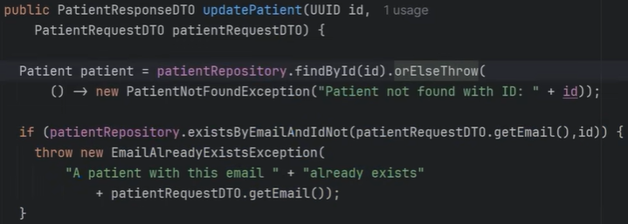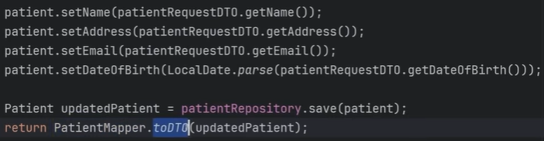
    - We find if ID exists else, we throw an exception.
    - We find if the email already exists, if yes, we throw an exception.
    - If checks passed, we update the Patient patient model with the request parameters.
    - We save the patient entity to the DB.
    - We convert the patient entity to a **ResponseDTO** and return to the Controller.
* 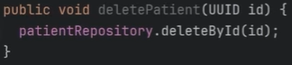

**Mapper**

* Create New Package. (com.pm.patientservice.**mapper**)
* New Class. **PatientMapper** class.
* This class will help to keep code modular and clean.
* The **PatientMapper** class shown in the image demonstrates a **manual mapping** approach to convert a **Patient** entity object into a **PatientResponseDTO** object. This specific method is designed to be used within the **PatientService** for security purposes by controlling which data is exposed via the API.
* **public class PatientMapper {**

**// This method takes a 'Patient' entity (the database representation)**

**// and returns a 'PatientResponseDTO' (the API representation).**

**public static PatientResponseDTO toDTO (Patient patient) {**

**// 1. Instantiate the new DTO object**

**PatientResponseDTO patientDTO = new PatientResponseDTO();**

**// 2. Manually copy properties from the entity to the DTO**

**patientDTO.setId(patient.getId().toString());**

**patientDTO.setName(patient.getName());**

**patientDTO.setAddress(patient.getAddress());**

**patientDTO.setEmail(patient.getEmail());**

**// Date is converted to String format for the API response**

**patientDTO.setDateOfBirth(patient.getDateOfBirth().toString());**

**// 3. Return the populated DTO**

**return patientDTO;**

**}**

**}**

**Controller**

* Create New Package. (com.pm.patientservice.**controller**)
* New Java Class. **PatientController().**
* // PatientController.java

// This class is part of the 'controller' layer in a Spring Boot application,

// responsible for handling incoming HTTP requests.  
  
*// Marks this class as a REST Controller. It handles requests and automatically*

*// serializes return objects (like the List of DTOs) into formats like JSON.*

**@RestController**

*// Maps all requests starting with "/patients" to this controller class.*

**@RequestMapping("/patients")**

**public class PatientController {**

*// Declares a dependency on the PatientService interface.*

*// The 'final' keyword ensures this dependency is set upon initialization.*

**private final PatientService patientService;**

*// Constructor-based Dependency Injection (the preferred method in Spring).*

*// Spring automatically provides an instance of PatientService when PatientController is created.*

**public PatientController(PatientService patientService) {**

**this.patientService = patientService;**

**}**

*// Maps HTTP GET requests (e.g., GET http://localhost:8080/patients)*

*// to this specific method.*

**@GetMapping**

**public ResponseEntity<List<PatientResponseDTO>> getPatients() {**

*// Calls the business logic layer (Service) to retrieve patient data.*

*// The service returns a List of DTOs (Data Transfer Objects), not raw Entities.*

**List<PatientResponseDTO> patients = patientService.getPatients();**

*// Wraps the list in a* ***ResponseEntity****, which allows us to customize*

*// the HTTP response status (here, HTTP 200 OK) and the body (the list of patients).*

**return ResponseEntity.ok().body(patients);**

**}**

**}**

* **@RestController** and **@RequestMapping** are two essential Spring Boot annotations used for creating RESTful web services.
  + **@RestController** is a specialization of the standard **@Controller** annotation and is used to define a class that handles web requests in a REST API.
    - **Key** **Function**: It tells Spring that the class's methods should return data directly (like JSON or XML), rather than a view template (HTML page). It combines @Controller and @ResponseBody automatically.
    - **Purpose**: Simplifies building APIs for frontends like mobile apps or single-page web applications.
  + **@RequestMapping**("/patients") annotation is used to map specific web request URLs/endpoints to either a class or a specific handler method.
    - **Key** **Function**: When used at the class level (as seen here), it defines the base URL path for all methods within that controller. In this case, every method inside **PatientController** will respond to URLs starting with ***/patients***.
    - For example, a **@GetMapping("/1")** method inside this class would handle a request for the full URL ***/patients/1***.
* **ResponseEntity** class is a fundamental component for building robust REST APIs. It represents an entire HTTP response, including the **status code**, **headers**, and the **body** (the actual data).
  + When you return a plain Java object (like a **List**<**PatientResponseDTO**>) from a @**RestController**, Spring automatically serializes it to JSON and returns an HTTP 200 OK status by default.
  + However, using **ResponseEntity** gives you fine-grained control to specify exactly what the response should look like.
  + For example, **return ResponseEntity.ok().body(patients);**
* **Add a @PutMapping method:**
  + This method receives a UUID along with the Put request which then calls the Service layer **updatePatient** method to update patient with the new parameters in the **patientRequestDTO** (which it receives/injected into this Put method directly via @RequestBody).
  + 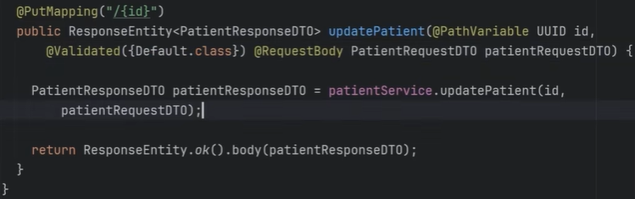
* **Add a @DeleteMapping:**
* 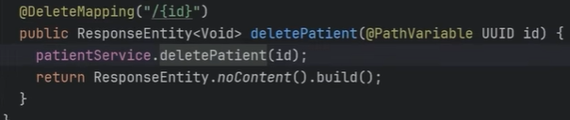

**API Requests**

* Go to the root of the project and create a **new Folder** called **‘api-requests.’ (patient-management/api-requests)**
* This folder will contain api-requests for each of our microservices. So we need to create a folder for each microservice.
* Create a New Folder called **api-requests/patient-service**
* Create a New HTTP Request called **‘get-patients.http’**
  + 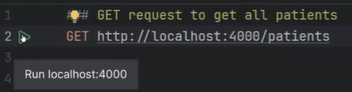
  + Make sure your patient-service microservice application is started before you run the HTTP request. If your DB has data, real or seeded, you should see a ResponseEntity/JSON object with your returned JSON response:
    - 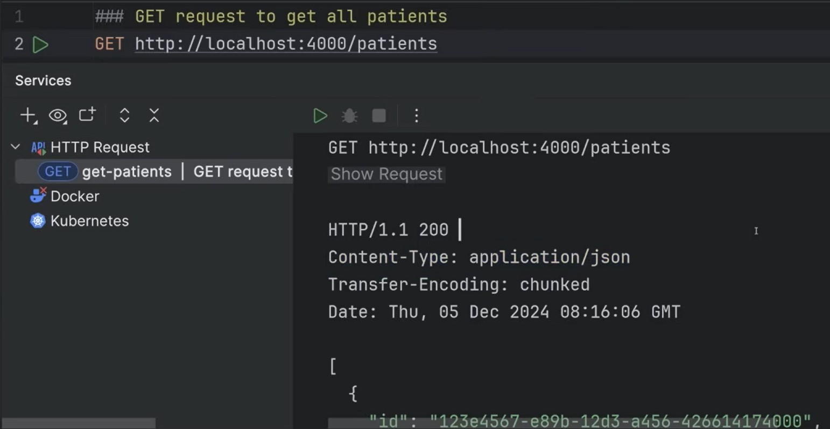
* **update-patient.http:  
  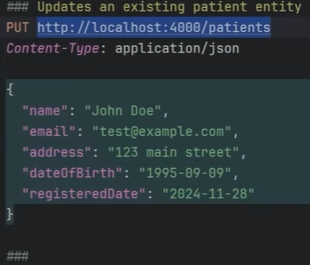**

**Request DTO**

* In a Spring Boot microservice, we use different DTOs (Data Transfer Objects) depending on whether data is
* entering the system or leaving it. This ensures maximum security and flexibility.
* **Request DTO (The "Input")** 
  + **Direction**: Client → Controller → Service.
  + **Purpose**: Used to capture data sent by the user (e.g., a registration form or an update request).
  + **Key** **Characteristics**:
    - Contains fields needed to create or modify a record.
    - **Validation**: Heavily uses validation annotations like @NotBlank, @Email, or @Min to ensure incoming data is correct before it reaches your business logic.
    - **Security**: Never includes fields the user shouldn't control, like accountBalance, role, or internalId.
* **Response DTO (The "Output")** 
  + **Direction: Service → Controller → Client.**
  + **Purpose**: Used to format the data being sent back to the user.
  + **Key** **Characteristics**:
    - Contains fields the user needs to see.
    - **Data** **Masking**: Excludes sensitive data (like passwordHash or ssn) that exists in the database Entity but should not be public.
    - **Formatting**: May include computed fields, like fullName (joining firstName + lastName) or a formatted dateOfBirth string.
* In the **com.pm.patientservice/dto** folder, create a New Java Class called **PatientRequestDTO**
* Add all the properties that we expect from the HTTP request and will need for our service.
* **Request DTO** designed for data entry. It uses **Bean Validation (Jakarta Validation)** to ensure that the data sent by a client (like a mobile app or web form) is clean and valid before the application processes it.
  + ***Notice that dateOfBirth and registeredDate are defined as String rather than LocalDate.***
    - Why? In Request DTOs, it is often easier to accept dates as Strings from a JSON request and then validate/parse them into proper Date objects in the Service Layer or via specialized converters.

**IMPLEMENTING SAVING PATIENT RECORDS TO THE DATABASE via AN HTTP POST REQUEST {@PostMappoing}**

First lets implement the **PatientRequestDTO**:

* **public class PatientRequestDTO {**

// Ensures the name is not empty and protects the DB from overly long strings

**@NotBlank(message = "Name is required")**

**@Size(max = 100, message = "Name cannot exceed 100 characters")**

**private String name;**

// Automatically validates standard email formats (e.g., name@domain.com)

**@NotBlank(message = "Email is required")**

**@Email(message = "Email should be valid")**

**private String email;**

**@NotBlank(message = "Address is required")**

**private String address;**

// Received as String for easier JSON parsing;

// will be converted to LocalDate in the Service/Mapper layer

**@NotBlank(message = "Date of birth is required")**

**private String dateOfBirth;**

**@NotNull(message = "Registered date is required")**

**private String registeredDate;**

// --- Standard Getters and Setters would follow ---

IMPLEMENT THE **CreatePatient** METHOD IN THE SERVICE CLASS

* NOW IN THE **PatientService** class, we implement the following method of using the above **PatientRequestDTO**.
  + **public PatientResponseDTO createPatient(PatientRequestDTO patientRequestDTO) {**

// This saves a new patient to the DB using the request information and returns a New ResponseDTO!

**Patient newPatient = patientRepository.save(  
 PatientMapper.toModel(patientRequestDTO)) ;**

**return PatientMapper.toDTO(newPatient) ;**

**}**

* + **toModel(PatientRequestDTO patientRequestDTO):** This method does the reverse of the **toDTO** method [*Which converts a rich domain****entity****(the database object) into a streamlined****response DTO****(the object sent to the client/API)*]: it takes data coming into the system (the **RequestDTO**, which has been validated) and converts it into a Patient entity object that can be persisted (saved) to the database.

CREATE A POST REQUEST (@PostMapping) IN THE CONTROLLER CALLED **createPatient**

* **@PostMapping** //Data is sent to create a new resource

**public ResponseEntity<PatientResponseDTO> createPatient(@Valid @RequestBody PatientRequestDTO request) {**

// If any validation fails (e.g., email is invalid),

// Spring will automatically return a 400 Bad Request error.

**PatientResponseDTO patientResponseDTO =   
 patientService.createPatient(patientRequestDTO);**

***return ResponseEntity.ok.body(patientResponseDTO);***

**}**

* **REST API endpoint** in a Spring Boot controller used to **create a new patient record**.
* The method is set to return a ResponseEntity. This gives full control over the HTTP response, and specifically declares that the body of the successful response will be a PatientResponseDTO object.
* **@RequestBody PatientRequestDTO request:** This tells Spring to take the entire incoming JSON request body and automatically convert it into an instance of the **PatientRequestDTO** class.
* **@Valid:** This is a crucial annotation. It tells Spring to trigger the Jakarta Bean Validation checks (like @NotBlank, @Email, etc.) that we defined in the PatientRequestDTO class.
* Now you can create a **create-patient.http** file in the **api-requests** folder and send a **POST request** with valid or invalid data in the body to test the flow.
  + **### Creates a new patient entity POST http://localhost:4000/patients Content-Type: application/json**

**{**

**"name": "John Doe",**

**"email": "test@example.com",**

**"address": "123 main street",**

**"dateOfBirth": "1995-09-09",**

**"registeredDate": "2024-11-28"**

**}**

* + 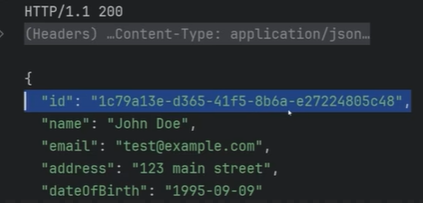
  + *The* ***id*** *was added via persisting the record to the DB, so we know it worked!*

**NOW THE FINAL FLOW OF EXECUTION FOR THE POST REQUEST IN WHICH WE SAVE/PERSIST PATIENT RECORDS TO THE DB**

* 1. **Request Arrives:** A client sends a POST request with a JSON body to **/patients.**
  2. **Validation:** Spring intercepts the data and runs the **@Valid** checks.
     + **If valid:** Execution continues to the **patientService.create(request**) line.
     + **If invalid:** Spring automatically stops execution and immediately sends back an HTTP 400 Bad Request error to the client, telling them which fields were incorrect (e.g., "Email should be valid").
  3. **Business Logic:** The valid request DTO is passed to the **patientService**, where it's mapped to an Entity and saved to the database. The service returns a **PatientResponseDTO**.
  4. **Response Sent**: ResponseEntity.ok() wraps the result in an HTTP 200 OK status code and sends the **new PatientResponseDTO** (as JSON) back to the client.

This entire mechanism showcases Spring's ability to automate validation and response handling, keeping your controller code clean and focused on orchestration.

**Exceptions**

* Create New Package. (com.pm.patientservice.**exception**)
* Create a New Class called **GlobalExceptionHandler:**
* 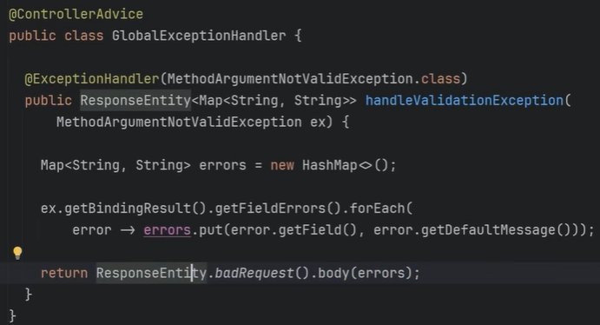
* **GlobalExceptionHandler**: designed to centralize and standardize how validation errors are presented to API clients. Instead of letting the application return a generic error message, this class catches specific exceptions and generates a clean, readable JSON response.
* **@ControllerAdvice:** A special annotation that makes this class **a global interceptor** for **exceptions** thrown by any @Controller or @RestController in the application.
* **@ExceptionHandler(...):** This annotation specifies which type of exception this specific method should handle. Here, it catches **MethodArgumentNotValidException**, which is automatically thrown by Spring whenever a @Valid check fails in a controller.
* The method returns a **ResponseEntity**, giving full control over the HTTP status code and response body. The body is a Map where keys are the field names (e.g., "email") and values are the error messages (e.g., "Email should be valid").
* **ex.getBindingResult().getFieldErrors().forEach(...):** This is a Java 8 Stream operation. It iterates through every field that failed validation in the original exception (ex) and collects the field name and its corresponding error message.
* **return ResponseEntity.badRequest().body(errors):** This returns a final response to the client with an HTTP 400 Bad Request status code, and the map of validation errors as the JSON body.
* **SUMMARY OF THE FLOW:**
  + When you use **@Valid** in a controller (as seen previously), if validation fails, Spring throws the **MethodArgumentNotValidException**. This global handler immediately catches that exception and transforms the ugly, raw error into a clean, structured JSON response like this:
    - {

"name": "Name cannot exceed 100 characters",

"email": "Email should be valid"

}

* + This ensures that the client receives meaningful feedback instead of a server error stack trace.
* **Create and use Custom Exception Class**
  + Create a New {**Exception**} Class called **EmailAlreadyExistsException:**

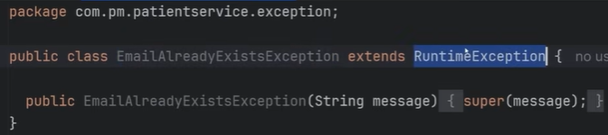

* + Add this to the **GlobalExceptionHandler:**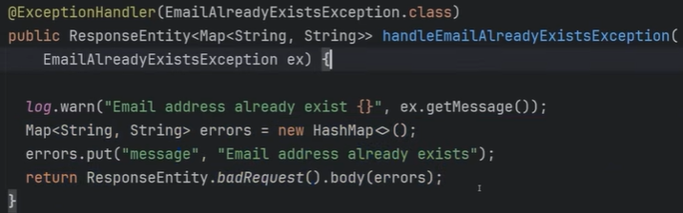
    - **Logger** being used here for development -----
  + **The custom exception is used in the service class:**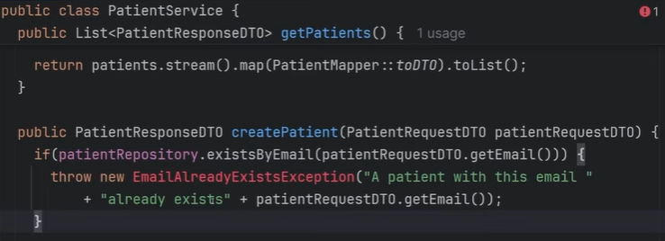
* **You could add another custom exception the same way:**
  + Create a New {**Exception**} Class called **PatientNotFoundException:**
  + Add this to the **GlobalExceptionHandler:**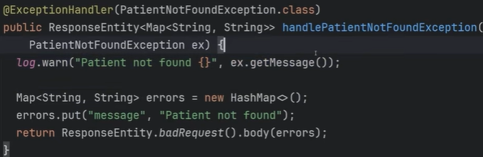
  + **Use it in the updatePatient method of the PatientService class:**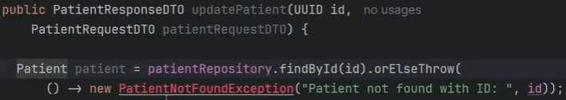

**Business Logic Validation in the Service Layer**

* **Business Logic:** **business logic** (or domain logic) refers to the core rules and procedures that determine how a business creates, transforms, and manages its data. These rules are derived from real-world requirements rather than technical constraints.
  + **Business logic** is primarily housed in the **Service Layer** (classes annotated with @Service). This layer acts as an intermediary between the Controller (Web/API) and the Repository (Data Access). **Technical logic** is everything else (Controller, Repository, DB, Security Config, Authentication, Authorization, etc).
  + **Examples of Business Logic:** Business logic is often characterized by "if-then" scenarios that define a business's unique operations:
    - **Data Integrity & Uniqueness**: Requiring that an email address must be unique across the system.
      * Registration Rule: IF a user's email already exists in the database, THEN throw a "Duplicate Email" error.
      * Financial Rule: IF a checkout total is less than $10, THEN reject the transaction with a "Minimum amount not met" message.
    - **Eligibility Rules:** Checking if a patient is within a specific age range or distance to qualify for a particular treatment.
    - **Calculations:** Automatically applying a 10% discount if an order exceeds a certain amount.
    - **Compliance:** Ensuring a user is over 18 years old before allowing them to open a financial account.

**Validators and @Validated**

* In Spring Boot, **validators** are components that enforce data integrity by checking that incoming information follows specific rules before it is processed by your business logic. They act as a first line of defense against corrupt or malicious data.  
  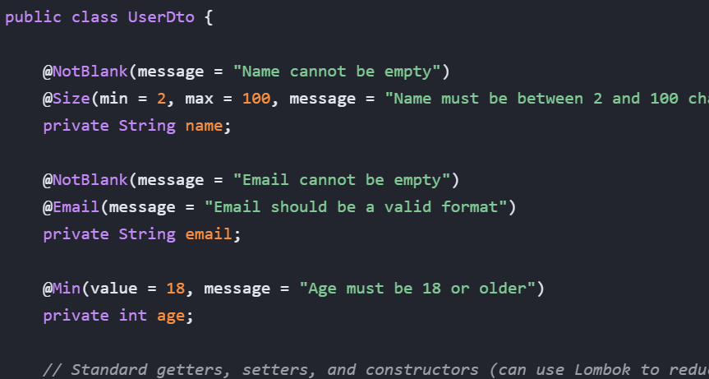
* **How Validation Groups Affect the Response**
  + **Validation Only**: Tagging a field with a group (e.g., **groups = CreatePatientValidationGroup.clas**s) simply tells Spring: "Only check this specific constraint when I use ***@Validated(CreatePatientValidationGroup.class***)".
  + **Or only run validation on the fields which I tag with the (groups = CreatePatientValidationGroup.clas**s) interface.
* **What is CreatePatientValidationGroup?**
  + CreatePatientValidationGroup is a **Validation Group**, which is a marker interface used to categorize validation rules.
  + Standard validation applies to all fields every time. However, business requirements often change depending on the action (context). For example:
  + **On Create:** A social security number might be mandatory.
  + **On Update:** The social security number might be read-only and not allowed in the request body at all.
* **How to use it**

To implement this, follow these three steps:

* + **Define the Group:** Create a simple empty interface.
    - **public interface CreatePatientValidationGroup {}**
  + **Assign the Group in your DTO:** Tag specific fields with this group.
    - **public class RequestDTO {**

**@NotBlank(groups = CreatePatientValidationGroup.class, message = "Name is required for new patients")**

**private String name;**

**@Email(message = "Email must be valid") // No group means it runs in the "Default" group**

**private String email;**

**}**

* **Trigger the Validation in the Controller:** Use @Validated instead of @Valid to specify which group to check.
  + **@PostMapping("/patients")**

**public void createPatient(@Validated(CreatePatientValidationGroup.class) @RequestBody PatientDTO dto) {**

// Only validations tagged with **CreatePatientValidationGroup** will run

}

* By using a group like CreatePatientValidationGroup, you can tell Spring to only run specific checks during the "Create" process.
* **@Validated(Group.class):** Tells Spring to only validate constraints tagged with Group.class.
* Validation groups only control **when** a rule is checked; they do not automatically exclude fields from a JSON response. If you want to hide fields from the response, you must use a separate mechanism like Jackson's **@JsonIgnore** or different DTOs.
* 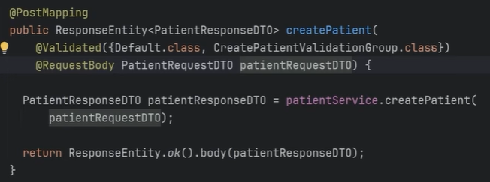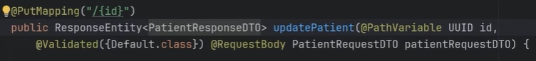  
  **Yes**, the code snippet you provided will check all validation constraints that belong to **both** the Default group and the **CreatePatientValidationGroup**.
* **How @Validated Works with Multiple Groups**

When you provide an array of classes to the @Validated annotation, you are explicitly activating every group listed.

* + **@Validated({Default.class, CreatePatientValidationGroup.class})**

1. **Default.class:** This is the default group used by any validation constraint (e.g., @NotBlank, @Email, @Min) that does not explicitly specify a groups attribute. It covers all "basic" validations applied universally.
2. **CreatePatientValidationGroup.class:** This specifically activates any constraints you explicitly tagged with **groups = CreatePatientValidationGroup.class** in your PatientRequestDTO.
3. **In the @PutMapping method, all fields in the RequestDTO that are marked with groups = CreatePatientValidationGroup.class (registeredDate field) are going to not be validated and *are going to be ignored* because it is not included in the @Validated().**
   * The validation process effectively merges the rules from both groups for this specific method execution. If any constraint in either group fails, Spring will stop execution and return a 400 Bad Request error before the code even reaches the service layer call.

**OpenAPI**

* OpenAPI is the industry-standard specification (a "blueprint") for describing RESTful APIs. While the terms are often used interchangeably, there is a distinct difference between them.
* **OpenAPI vs. Swagger**
  + **OpenAPI** is the Specification: It is a machine-readable JSON or YAML file that defines exactly how your API works—including endpoints, input parameters, and return types.
  + **Swagger** is the Toolset: It refers to the suite of tools (like Swagger UI, Swagger Editor, and Swagger Codegen) used to implement and visualize that specification.
* In a Spring Boot environment, you typically use a library like **Springdoc** **OpenAPI** to bridge these two concepts:
  + **Generation**: The library scans your code to generate an OpenAPI document (the blueprint) at /v3/api-docs.
  + **Visualization**: It then uses Swagger UI to turn that blueprint into the interactive webpage you use to test your services.
  + **Contract-First Development**: Many modern teams use an "API-first" approach, where they write the OpenAPI specification before any Java code is written, ensuring all microservices follow a pre-agreed contract.

**Swagger**

* Swagger is an open-source framework and set of tools used for designing, building, documenting, and consuming RESTful APIs. In the context of Java Spring microservices, it automates the creation of interactive and machine-readable API documentation, making the APIs easier to understand, test, and integrate across different services.
* **Swagger and the OpenAPI Specification (OAS)**
  + It is important to note the distinction:
  + **OpenAPI Specification (OAS)** is a standardized, language-agnostic definition format (YAML or JSON) for REST APIs. It was formerly known as the Swagger specification.
  + **Swagger** is the popular suite of tools (like Swagger Editor, Swagger UI, and Swagger Codegen) that work with the OpenAPI specification to facilitate the API lifecycle.
* **Role in Java Spring Microservices**
  + In a Spring Boot microservices architecture, Swagger (typically implemented using the springdoc-openapi library) provides several key benefits:
  + **Automated Documentation:** By using annotations like @Operation, @ApiResponse, and @Parameter in your Java code, Swagger automatically generates comprehensive and up-to-date documentation that stays in sync with the actual code implementation.
  + **Interactive UI (Swagger UI):** It provides a web-based interface (accessible at a URL like http://localhost:8080/swagger-ui/index.html by default) that allows developers to visualize and interact with the API endpoints directly in the browser, without needing external tools like Postman. Users can test different HTTP requests (GET, POST, PUT, DELETE) and see the responses.
  + **Improved Collaboration:** It acts as a clear contract between frontend and backend development teams, reducing manual documentation effort and potential inconsistencies.
  + **Code Generation**: Swagger Codegen can generate client libraries (SDKs) and server stubs in over 40 languages from the OpenAPI specification file, streamlining integration with other services.
  + **Microservices Management**: In an environment with many microservices, each with its own API, Swagger can be centralized (often at an API Gateway level) to provide a single, unified interface for accessing all the services' documentation, which simplifies management and discovery.
* Essentially, Swagger helps turn the complexity of numerous independent microservices into a manageable and well-documented system.

**Springdoc OpenAPI**

* Springdoc OpenAPI is the standard open-source library used to automate the generation of API documentation for Spring Boot applications. It has effectively replaced the older, now-obsolete Springfox library.
* **Core Functionality**
  + Springdoc OpenAPI works by examining your Spring application at runtime. It looks at your configurations, controller class structures, and annotations to infer what your API does, then automatically generates:
    - ***OpenAPI*** ***3***.***1*** ***Blueprint***: A JSON/YAML file (usually at /v3/api-docs) that describes your entire API.
    - ***Interactive*** ***UI***: A built-in Swagger UI (at /swagger-ui/index.html) where developers can view and test endpoints directly.
    - ***Modern*** ***Alternatives***: Support for newer, high-performance UIs like Scalar.
* **Function of the @Tag Annotation**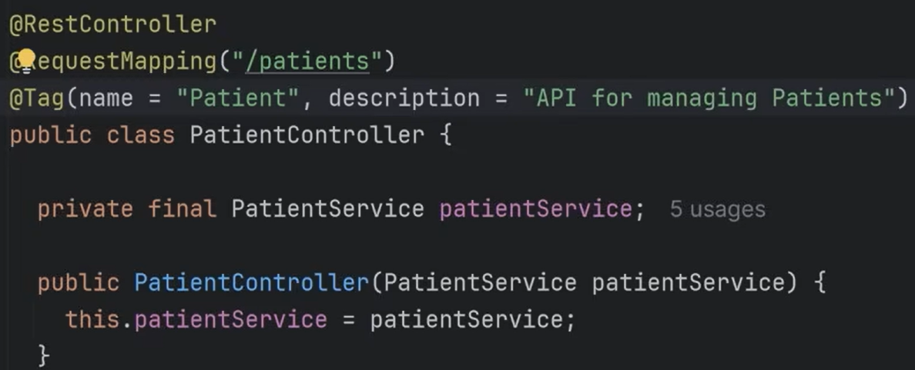
  + The **@Tag** annotation is used in Spring Boot applications to organize and add human-readable metadata to the generated API documentation (the OpenAPI specification).
  + **Grouping Endpoints**: When applied at the class level, as in the image's **PatientController**, it groups all the API operations (methods) within that controller under a single logical tag in the interactive Swagger UI.
  + ***The Name attribute is usually the name of the Entity that the Controller is going to control (eg. Patient)***
* **Providing Context**: The name and description attributes provide a clear label and summary for that group of endpoints, making the documentation easier for developers to navigate and understand.
* **Generating Global Tags**: By providing both a name and a description, the tag is automatically added to the global tags section of the OpenAPI specification file itself, which can influence how the documentation is sorted and displayed.
* In this specific case, all endpoints within the PatientController will be listed under the heading "**Patient**" (**ENTITY**) with the description "API for managing Patients" in the generated Swagger documentation interface.
* **@Operation** annotation is used directly on your @GetMapping methods to add specific **summary** and **description** details that appear in the **Swagger UI** documentation.
* **@Operation(**

**summary = "Retrieve a patient record by their ID",**

**description = "Provides full details for a single patient using their unique database identifier."**

**)**

**@ApiResponses(value = {**

**@ApiResponse(responseCode = "200", description = "Successfully retrieved the patient details"),**

**@ApiResponse(responseCode = "404", description = "Patient ID not found in the system")**

**})**

**@GetMapping("/patients/{id}")**

**public Patient getPatientById(@PathVariable Long id) {**

**// Method implementation goes here**

**return new Patient();**

**}**

* **summary**: A short, high-level title for the operation (e.g., "Retrieve a patient record by ID").
* **description**: A longer, detailed explanation of what the endpoint does.
* **@ApiResponses**: (Optional, but highly recommended) This nested annotation is used to explicitly define all possible HTTP response codes the API might return, which vastly improves clarity for consumers of your API.

**Swagger Editor**

* Pasting the generated **v3/api-docs** file into the [Swagger Editor](https://editor.swagger.io/) allows you to perform several crucial tasks, moving beyond simple visualization to actively refining, testing, and leveraging your API definition as a contract.  
  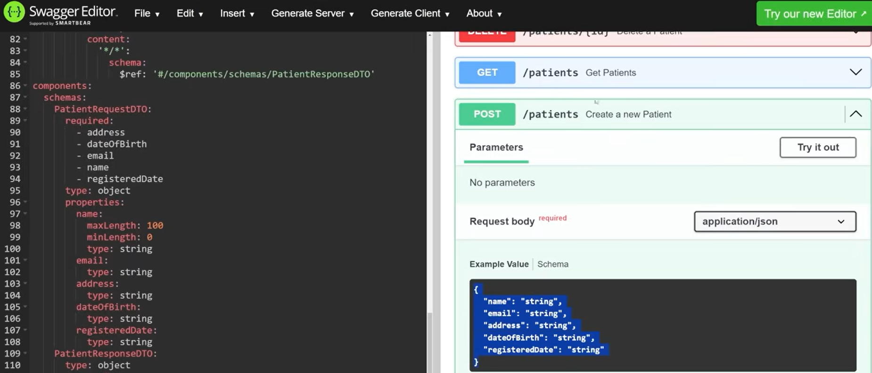
* **Key Activities in Swagger Editor**
  + **Real-time Validation and Error Checking:** The primary function is to validate that your generated JSON/YAML file strictly adheres to the OpenAPI Specification (OAS) standards. The editor highlights any syntax errors, structural issues, or missing required fields in real-time, helping you catch mistakes that might not be obvious from the code generation process alone.
  + **Manual Refinement and Enhancement:** You can manually add details that are hard to capture via code annotations alone, such as:
    - **Rich Descriptions:** Adding long, multi-line descriptions with Markdown formatting to provide better context.
    - **Examples:** Providing clear examples of request and response bodies to make the API easier to understand for consumers.
    - **Security Definitions:** Explicitly defining authentication methods like OAuth2 or API keys in detail.
  + **Interactive Testing ("Try it out"):** The editor features a live, interactive documentation preview (Swagger UI) that lets you make actual API calls directly in the browser. You can fill in parameters and see the real responses from your running Spring Boot application, serving as a built-in testing tool.
  + **Code Generation:** Using the "Generate Server" or "Generate Client" options, you can automatically scaffold boilerplate server code (in languages like Node.js, Python, or even more Java options) or client SDKs in over 40 languages. This is especially useful for a "design-first" approach or for quickly providing client libraries to consumers.
  + **Conversion:** You can easily convert the file between JSON and YAML formats with a single click if your team prefers one over the other.
  + **Collaboration:** For teams using a platform like SwaggerHub (which integrates the editor), you can collaborate in real-time on the API definition, track changes using version control, and enforce organizational design standards.
* By using the **Swagger Editor**, you ensure your API is not just documented, but robust, standardized, and easy for other developers to consume and integrate with.

**Docker**

* **Docker** is the industry-standard platform for "containerization," a technology that allows you to package an application and all its requirements into a single, portable unit called a **container**.

1. **What does Docker solve?**

* Before Docker, developers often faced the "it works on my machine" problem—an application running perfectly in development would fail in production due to different library versions, OS patches, or configurations. Docker solves this by:
  + **Environment Consistency:** Ensuring the application runs exactly the same on a laptop, a test server, and a cloud environment.
  + **Dependency Isolation:** Preventing conflicts between different apps (e.g., App A needs Java 17 while App B needs Java 21) by giving each its own isolated workspace.
  + **Resource Efficiency:** Unlike Virtual Machines (VMs), which duplicate an entire Operating System, Docker containers share the host's OS kernel, making them much lighter and faster to start.

1. **How does Docker work?**

* Docker uses a client-server architecture where a **Docker Client** (your command line) sends instructions to the **Docker Daemon** (the "brain") to manage three primary components:

1. **The Source Code & Build Process (Dockerfile)**

* You write a **Dockerfile**—a simple text file that acts as a blueprint. It tells Docker:
  + **FROM:** Start with a base "Image" (like a clean Linux or a specific Java version).
  + **COPY:** Bring your source code or compiled JAR file into the image.
  + **RUN:** Install necessary dependencies or libraries.

1. **The Static Blueprint (Image)**

* When you "build" the Dockerfile, it creates an **Image**. An image is a read-only, immutable snapshot containing your code, runtime, system tools, and libraries. It is built in **layers**, allowing Docker to cache and reuse parts that haven't changed to save time and space.

1. **The Runtime Environment (Container)**

A **Container** is a live, running instance of an image.

* + **Isolation:** Docker uses Linux kernel features called **namespaces** to give the container its own private view of the system (files, network, process IDs) and **cgroups** to limit how much CPU/RAM it can use.
  + **Ephemeral nature:** By default, any changes made inside a container are lost when it is deleted, which ensures every new instance starts from a known, clean state.

1. **Configurations & Dependencies**
   * **Configs:** Environment variables (like database passwords) are passed in at runtime, separating your code from its configuration.
   * **Dependencies:** Every library your app needs is "baked" into the image, so the host machine doesn't need anything installed except for the Docker Engine.

* 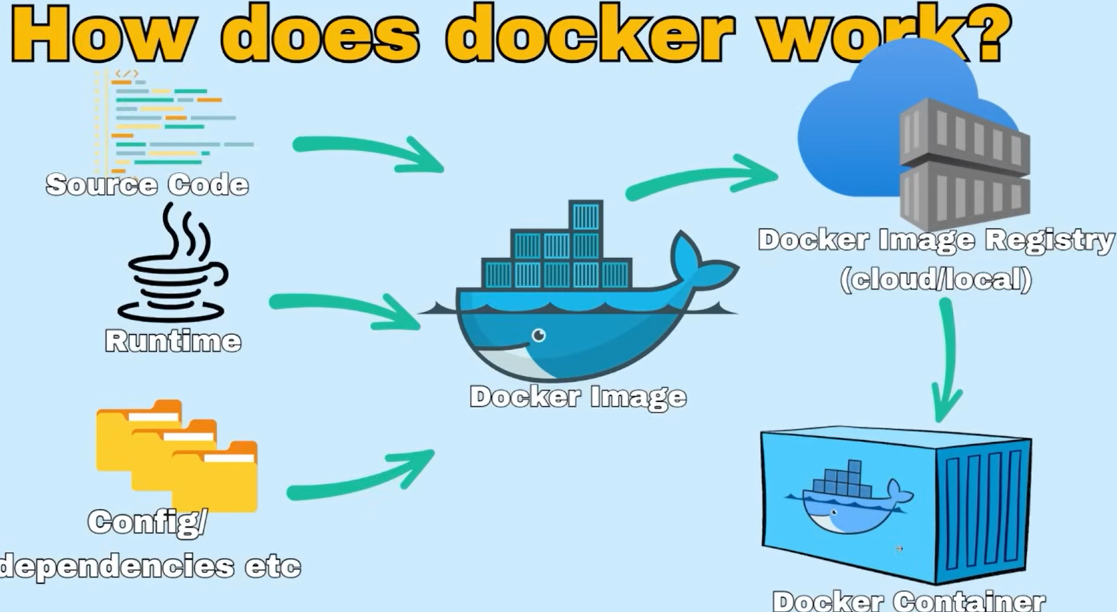

**IntelliJ IDEA (Ultimate Edition) offers deep, native integration for Docker that allows you to manage containers, images, and registries without leaving the IDE.**

* **To create and start a PostgreSQL container in IntelliJ (2026) using an existing image, follow these notes:**

1. **Pull the Image**
   * Click 3 dots menu (overflow menu) 🡪 click Edit under Configuration
   * Click +, Add New Configuration 🡪 Select Docker Image
   * Change Name from Docker Image to **patient-service-db**
   * ***Docker provides many out-of-the-box images that we can pull from the Docker Registry.***
   * For Image ID or name 🡪 Write **postgres:latest**
   * For Container name 🡪 write **patient-service-db**
   * Modify options 🡪 Environment variables 🡪 Click Folder icon 🡪 Enter vars like:  
     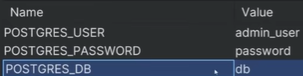
   * Expose a PORT on the container so we can access it from our IDE 🡪 Modify options 🡪 Bind ports 🡪 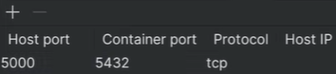
   * ***Port 5432 is the official default TCP port assigned for DB connections.***
   * Modify options 🡪 Bind Mounts  
     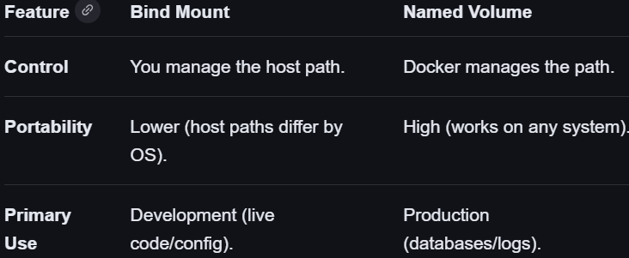
   * Modify options 🡪 Run options 🡪 **--network my_internal_docker_network**
   * Using --network internal (or a custom internal network) in your Docker run options is a security best practice for microservices. It isolates your database or backend from the public internet while still allowing your other containers to talk to it.
   * **What it Does:**
     + **External Isolation**: Containers on an internal network cannot access the outside internet, and the outside internet cannot access them.
     + **Inter-Container Communication**: Your Java Spring microservice can still connect to the PostgreSQL container as long as both are on the same network.
     + **Security**: This prevents sensitive services (like a database) from being exposed or making unauthorized outbound calls.
   * 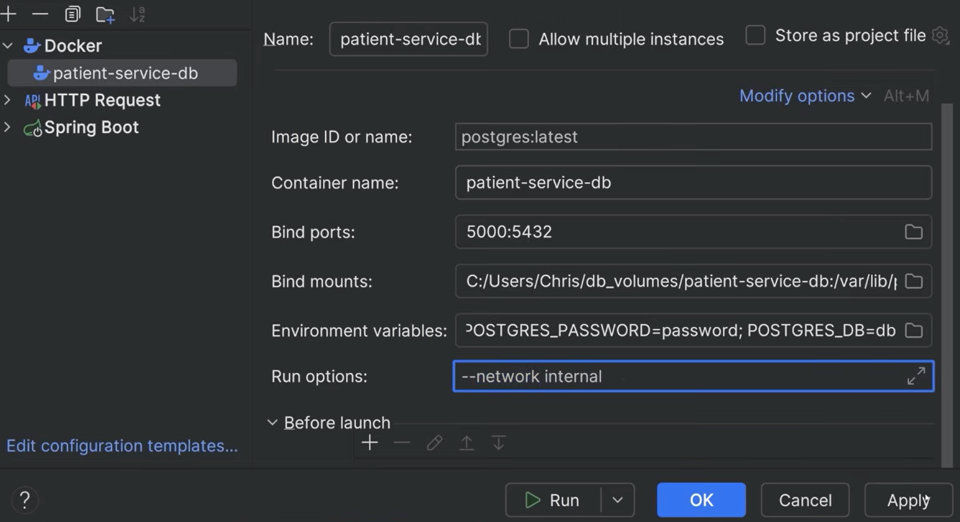
   * CLICK APPLY AND OKAY 🡪 **BUT BEFORE WE RUN THIS, WE NEED TO CREATE OUR NETWORK!!**
2. **Create the Docker Network**
   * Docker 🡪 Right-click Networks 🡪 Create Network 🡪 Enter network name 🡪 “**my_internal_docker_network**”
   * Click okay and you will see your network name:  
     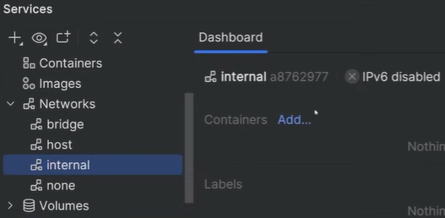
   * Click dropdown for recent configurations and select your Docker configuration (**patient-service-db**) 🡪 Click RUN button
   * Now its pulling the image, printing the logs from inside the docker container, creating a DB 🡪 “PostgreSQL init process complete; ready for start up”
   * The container is running and ready to accept connections. You will see a Green box with a green circle top-right:  
     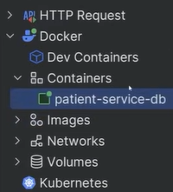 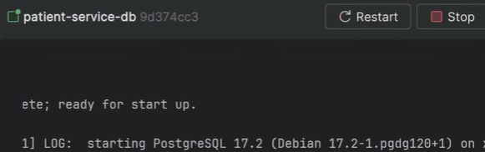
   * If you click on the Networks tab 🡪 the network you created ‘internal’ 🡪 you will see the container you just ran

* SO INTELLIJ USES THE SAME DOCKER CONTEXT AS THE ONE INSTALLED ON YOUR SYSTEM! You could also use the CLI or Docker Desktop.

1. **Create patient-service microservice**
   * We are going to create a dockerize **patient-service** that will be on the same docker network and connect to our dockerized pg container. This matches closer to our production environment. Benefits of this is we can catch issues early before deploying to production server because containerizing code can behave differently.
   * Let’s create out first dockerfile:
     + 🡪 A **Dockerfile** is essentially a **recipe** for creating a Docker Image. It is a plain text file containing a list of instructions that Docker follows to bake your application into a portable container.
       - Instead of manually installing Java, setting environment variables, and moving files every time you deploy, you write them once in this file.
     + Right-click patient-service app 🡪 New – Dockerfile 🡪 Dockerfile created!
     + Highly efficient type of Docker setup called a **multi-stage build**. These commands define the final, lightweight runtime environment for your Spring Boot microservice.
   * 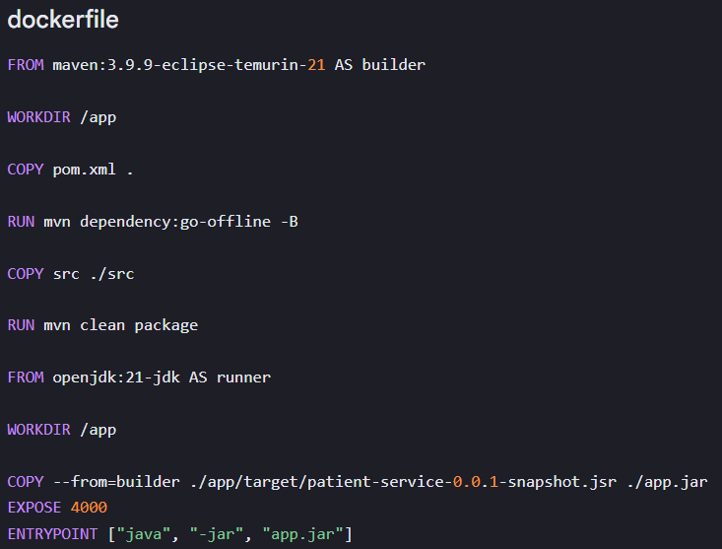
   * **What is the Builder Stage?**
     + The builder stage is the first, temporary environment defined in a multi-stage **Dockerfile** (**FROM maven:... AS builder**).
     + Its sole purpose is to provide the necessary heavy tools (like the full Maven build system and source code) to compile your application. Once the compilation is complete and the resulting JAR file is created, this entire "builder" environment is thrown away. This keeps your final production image lean and secure.
   * **What is a JAR File??**
     + A **JAR** (**Java** **Archive**) file is a single package that acts much like a ZIP file. It is the standard deployment format for Java applications.
     + **It** **contains**: All of your compiled Java bytecode (.class files) and any required configuration files or dependencies needed by your application.
     + **Purpose**: It bundles everything needed into one executable file, making it easy to distribute and run anywhere the Java runtime is installed.
   * The source files are compiled into the **JAR** file. To actually run the application, you need the Java Runtime Environment (**JRE**) (or **JDK**, as used in your second stage).
   * The **builder stage** handles the compilation part. The **runner stage** provides the necessary **JRE** (openjdk:21-jdk) to execute that compiled **JAR** file using thejava -jar app.jar command.

* Now again, Edit Configuration (overflow menu) 🡪 + Add new configuration 🡪 Dockerfile 🡪 Name: patient-service 🡪 Image tag: patient-service:latest 🡪 Container name: patient-service 🡪 Environment Variables:  🡪 Port Bindings 🡪 Run options: --network internal (*RUNNING ON SAME NETWORK AS OTHER CONTAINERS*) 🡪 comment out old redundant dev configurations in **application.properties** file.
  + 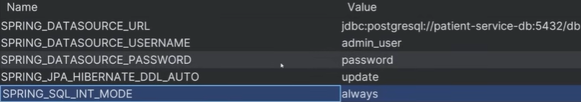
  + **HIT RUN**
  + 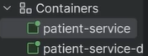 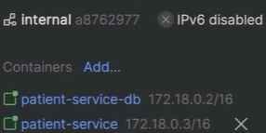  
    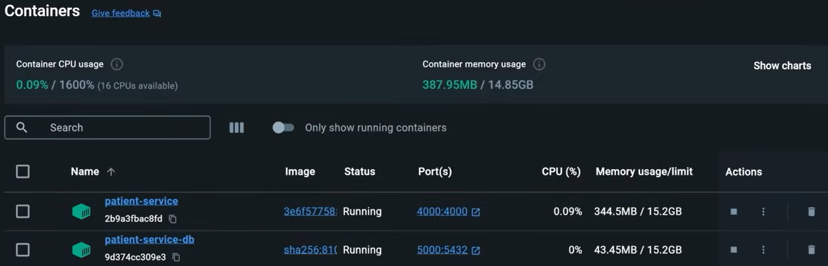
  + 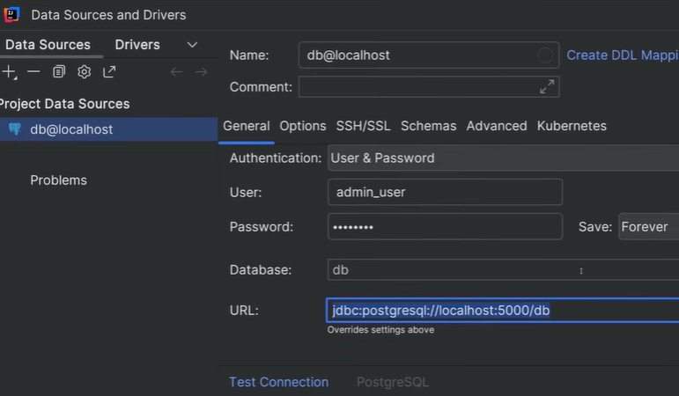
* You need to test the seeding, endpoints, db connections, db table autocreate, unit tests etc. If that works then:

***NOW YOU HAVE A COUPLE OF CONTAINERS THAT WILL RUN THE SAME WAY ON AWS!***

* **How Patient Service Connects to PGDB on the Same Network ^^**
  + This shows the key to inter-container communication: the SPRING_DATASOURCE_URL environment variable uses a container name as the network **hostname**.
  + **jdbc:postgresql://patient-service-db:5432/db**
  + This works because Docker has an embedded **DNS service** for user-defined networks.
  + **Shared Network:** Both the **patient-service container** (your Spring Boot app) and the **patient-service-db container** (PostgreSQL) must be explicitly connected to the **same user-defined network** (e.g., via docker network create my_network and running with --network my_network, or by using a docker-compose.yml file).
  + **Service Discovery:** The Docker DNS server intercepts the hostname **patient-service-db**and resolves it to that specific container's internal IP address.
  + **Direct Connection:** The connection is then made directly from container to container over their internal IP network on the specified port (**5432**). Port mapping to the *host machine* is not required for this internal communication.
* This setup is reliable because container IPs might change when they restart, but their **user-defined network name** remains constant, allowing services to always find each other.

**gRPC Architecture**

* So far, we have been using REST to interact between our Frontend and patient-service microservice to send and receive data. REST is good because it has good browser compatibility, uses JSON and works seamlessly over HTTP.
* **What is gRPC?**
  + **gRPC** (gRPC Remote Procedure Calls) is a high-performance, open-source framework used primarily for **internal microservices communication**. Originally developed by Google, it allows a client application to directly call a method on a server application as if it were a local function.
  + **How it Works (The "Secret Sauce")**
    - **gRPC achieves its extreme speed**—often 7–10x faster than REST—by combining two core technologies:
    - **Protocol Buffers (Protobuf):** Instead of using human-readable but bulky JSON, gRPC uses a binary serialization format. You define your data structures in a .proto file (a "contract"), and the compiler generates compact binary code that is much faster for machines to process.
    - **HTTP/2:** gRPC runs over HTTP/2, which supports multiplexing (sending many requests over one connection) and header compression. This drastically reduces network overhead compared to the standard HTTP/1.1 used by most REST APIs.
  + **Key Features**
    - **Strongly Typed Contracts:** The .**proto** file acts as a strict agreement between services, reducing bugs caused by mismatched data fields.
    - **Code Generation:** Using the **protoc** compiler, you can automatically generate client and server "stubs" in multiple languages (Java, Python, Go, etc.), making it ideal for polyglot environments.
    - **Bidirectional Streaming:** Unlike REST's simple request-response model, gRPC supports real-time, two-way streaming of data over a single connection.
    - **Language Agnostic:** A Java microservice can seamlessly call a Go or Python service using the same generated code patterns.
  + **Common Use Cases** 
    - **Internal Microservices**: It is the industry standard for "backend-to-backend" communication where performance is critical.
    - Real-Time Data: Powering live dashboards, chat systems, and video conferencing where low latency is required.
    - IoT & Mobile: Its compact message sizes are perfect for battery-constrained devices or low-bandwidth networks.
    - AI Infrastructure: Used for high-speed data transfer between model-serving infrastructure and client applications.
* While REST provides an excellent way for browsers and other Clients to communicate with services in JSON format, gRPC offers a faster and more efficient method for microservices to interact with each other utilizing the PROTOBUF format to send and receive data. While both use HTTP beneath the hood, gRPC is significantly faster and more efficient and is used internally for microservices interactions where high performance and low latency and necessary.
* 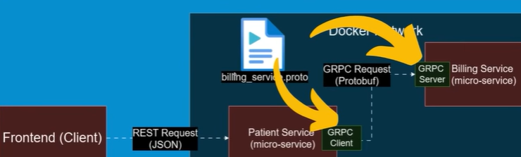
* The industry best practice when designing a gRPC architecture is to *name the* ***.proto*** *file after the primary service or domain it defines.*
* The **.proto** file's **purpose** in this architecture is to serve as the single, shared, and strict **contract** that both services use to generate their communication code.
* Both teams agree on the **contract** **during development**, and the code is generated as part of the build process.
* **Here is the step-by-step workflow for the communication shown in the image:**
  1. **Shared Contract:** A developer writes the **billing_service.proto** file. This file is shared and included in both the Patient Service project and the Billing Service project (usually via a shared code library or version control). ALL SERVICES NEED ACCESS TO THE **.PROTO** FILE.
  2. **Code Generation (Build Time):**
     + The **Billing Service** compiles the **.proto** file to generate a ***server skeleton*** or abstract interface that its developers must implement with their billing logic.
     + The **Patient Service** compiles the *same* **.proto** file to generate a ***client stub***. This stub is a local Java class that has methods like **calculateBill**(), which look like normal local functions to the Patient Service developers.
  3. **Runtime Execution (As seen in the image):**
     + The Patient Service code calls a method on its local **gRPC Client** (the auto-generated **stub**).
     + The stub automatically serializes the data into the compact **Protobuf** (binary) format and sends it over the network via HTTP/2.
     + The **Billing Service (gRPC Server)** receives the binary request, decodes it, runs its logic, and sends back a binary response using the same process.
* The result is a fast, strongly-typed function call from the Patient Service to the Billing Service, abstracting away all the complexities of network communication.

**BILLING SERVICE**

* Patient-management project folder 🡪 Create New Module *{Anytime we add a new module we are essentially creating a new microservice}* 🡪 Name: billing-service 🡪 com.pm.billingservice package created 🡪 Add dependencies: Spring Web
* 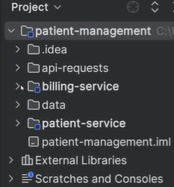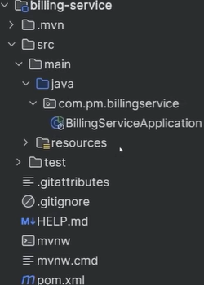
* Add the necessary **gRPC** and **Proto** dependencies to create our gRPC server with our billing-service
* billing-service > pom.xml 🡪 add quite a few dependencies for **gRPC** and **protobuf** in the **<dependencies>** section.
* 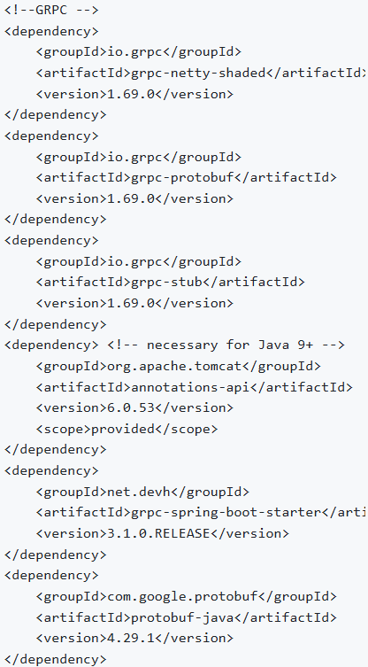 **Maven dependencies** required to integrate **gRPC** into a **Spring Boot** application using the popular **net.devh:grpc-spring-boot-starter** library.
* These dependencies have specific roles in enabling high-performance inter-microservice communication:
  + **grpc-netty**: Handles the fast network transport using HTTP/2.
  + **grpc-protobuf**: Manages data serialization in the compact binary format.
  + **grpc-stub**: Provides the foundational client/server code interfaces.
  + **net.devh:grpc-spring-boot-starter**: The "easy button" that automatically wires everything into your Spring context, allowing you to use @GrpcClient annotations seamlessly.
  + Essentially, these are the libraries you need to make your microservices talk to each other faster than traditional REST using strongly-typed, auto-generated code, without extensive manual configuration in Spring.
* Reload the pom.xml file so Maven applies the detected changes.
* 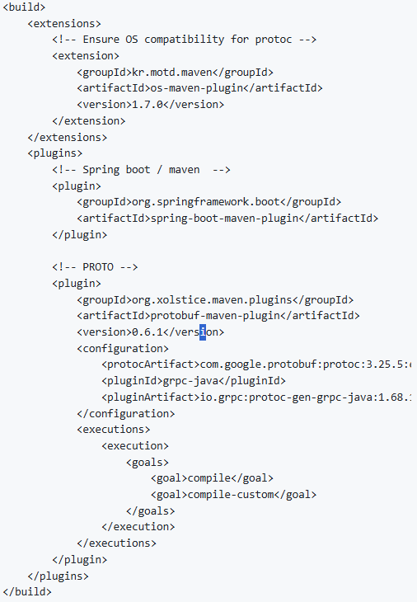Replace the <build> section with this:
  + **Maven build configuration** (pom.xml snippet) required to compile **gRPC Protocol Buffer** definitions into usable **Java code**. This process is essential for microservices to generate the necessary client and server code from the shared .proto contract file.
  + This Maven configuration is crucial for preparing your Java microservice for **Dockerization** and **AWS** **production** **deployment**. It ensures consistent builds and prepares the necessary application artifacts.
  + **os-maven-plugin:** **Ensures consistency:** Guarantees that the correct platform-specific gRPC compiler is used regardless of whether you are building on a Mac laptop or a Linux-based AWS build server. Prevents "it works on my machine" issues during the Docker build phase.
  + **spring-boot-maven-plugin:** **Creates the Artifact:** Compiles your Spring Boot application into the single, executable .jar file that your Dockerfile will later COPY into the final Docker image.
  + **protobuf-maven-plugin:** **Generates API Code:** Automatically converts your .proto contract files into strongly-typed Java code during the build. This ensures your service has the necessary gRPC client/server interfaces to communicate within your AWS microservices network.
  + ***In short, these plugins ensure your service is correctly compiled, packaged, and ready to be encapsulated into a portable Docker image that can reliably run in an AWS environment.***